HOTEL ROOM BOOKING SYSTEM
A PHP and MySQL Based Database Management System

1. Introduction
The Hotel Room Booking System is a database-driven application developed to store and manage guest details, room details and room booking transactions. It uses PHP to communicate with a MySQL database. The system allows the user to select check-in and check-out dates, view rooms available for the selected period, choose a guest and a room, and save the booking.
A separate report page displays booking information by combining data from the guest, room and booking tables. The report shows the guest name, room number, room type, check-in date and check-out date, along with additional booking details.

2. Objectives
- To create a database for storing guest, room and booking details.
- To organise the data into related tables using primary keys and foreign keys.
- To provide a PHP form for entering and saving room booking details.
- To check room availability for the selected check-in and check-out dates.
- To retrieve and display booking information using SQL JOIN operations.
- To prevent overlapping bookings for the same room and dates.

3. Software and Technologies Used

Technology | Purpose
PHP | Server-side programming, form processing and database queries.
MySQL | Storing guests, rooms and booking records.
XAMPP | Providing the local Apache web server and MySQL/MariaDB server.
phpMyAdmin | Creating, importing, viewing and managing the database and tables.
HTML | Creating the booking form and report page.
CSS | Styling the pages and arranging the form, room cards and report table.

4. Database Design
A database named hotel_db is created to store the information required by the application. It contains three tables: guest, room and booking. The guest and room tables store master data, while the booking table stores each room reservation transaction.
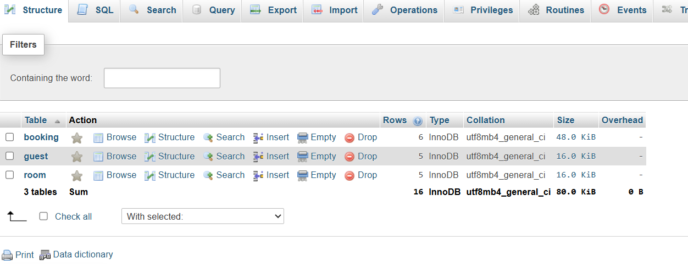
Figure 1: Database hotel_db showing the guest, room and booking tables.

5. Table Structures and Description

5.1 Guest Table
The guest table stores the basic details of each hotel guest. guest_id uniquely identifies each guest and acts as the primary key.
Field | Data type | Description
guest_id | INT | Primary key; uniquely identifies a guest.
name | VARCHAR(100) | Name of the guest.
city | VARCHAR(60) | City of the guest.
phone | VARCHAR(15) | Contact number of the guest.

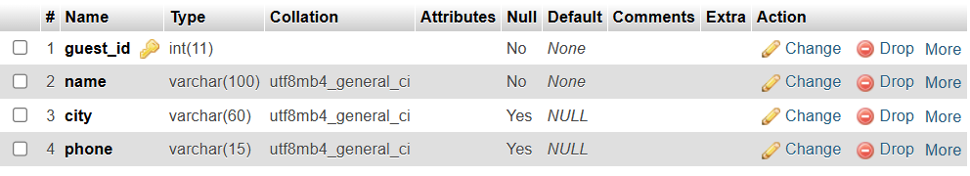
Figure 2: Structure of the guest table.

5.2 Room Table
The room table stores the details of the rooms available in the hotel. room_no is the primary key and uniquely identifies each room.

Field | Data type | Description
room_no | INT | Primary key; uniquely identifies a room.
room_type | VARCHAR(30) | Category or type of the room.
tariff_per_day | DECIMAL(10,2) | Room tariff charged per day.
floor | INT | Floor on which the room is located.

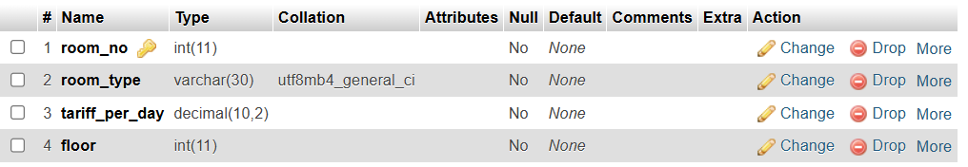
Figure 3: Structure of the room table.

5.3 Booking Table
The booking table stores each room booking transaction. booking_id is the primary key and is automatically generated. guest_id and room_no are foreign keys referring to the guest and room tables.
Field | Data type | Description
booking_id | INT, AUTO_INCREMENT | Primary key; automatically generated booking number.
guest_id | INT | Foreign key referring to guest.guest_id.
room_no | INT | Foreign key referring to room.room_no.
check_in | DATE | Date on which the guest checks in.
check_out | DATE | Date on which the guest checks out.

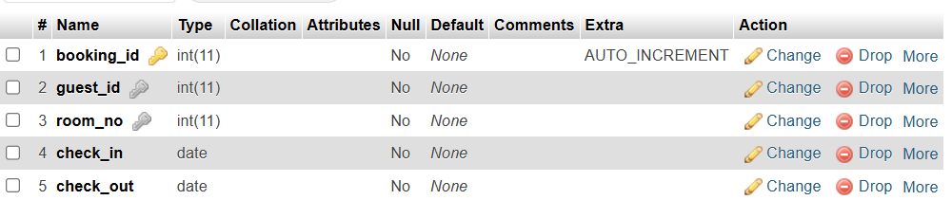
Figure 4: Structure of the booking table.

6. Records Stored in the Tables
Sample records are inserted into the guest and room master tables. These records are used by the booking form when selecting a guest and an available room. Booking records are stored in the booking table when the form is submitted. The supplied SQL export contains 50 guest records, 30 room records and 509 booking records.
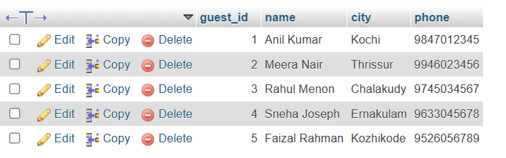
Figure 5: Guest table containing sample guest records.
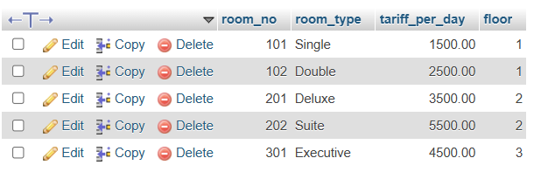
Figure 6: Room table containing sample room records.
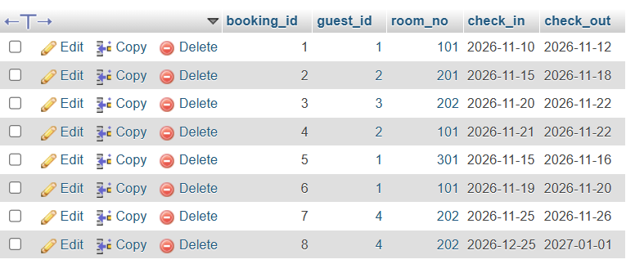
Figure 7: Booking table showing saved booking transactions.

7. Mechanism Used to Connect the Tables
The tables are connected using primary key and foreign key constraints. A primary key uniquely identifies each row in a table. A foreign key is a field in one table that refers to the primary key of another table.
- guest.guest_id is the primary key of the guest table.
- room.room_no is the primary key of the room table.
- booking.booking_id is the primary key of the booking table.
- booking.guest_id references guest.guest_id.
- booking.room_no references room.room_no.
Therefore, each booking is associated with an existing guest and an existing room. The foreign key constraints help maintain referential integrity and prevent a booking from referring to a guest or room that does not exist.
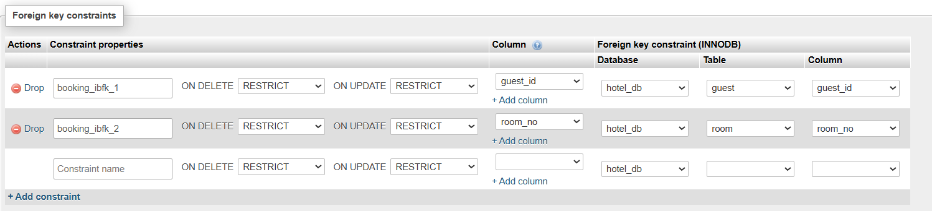
Figure 8: Relation view showing the two foreign key constraints.

8. Entity–Relationship (ER) Diagram
The ER diagram represents the relationship between the three entities. GUEST has a one-to-many relationship with BOOKING: one guest may make many bookings, but each booking belongs to one guest. ROOM has a one-to-many relationship with BOOKING: one room may have many bookings over time, but each booking refers to one room.

GUEST (1) ───── MAKES ───── (M) BOOKING
ROOM (1) ───── FOR ─────── (M) BOOKING

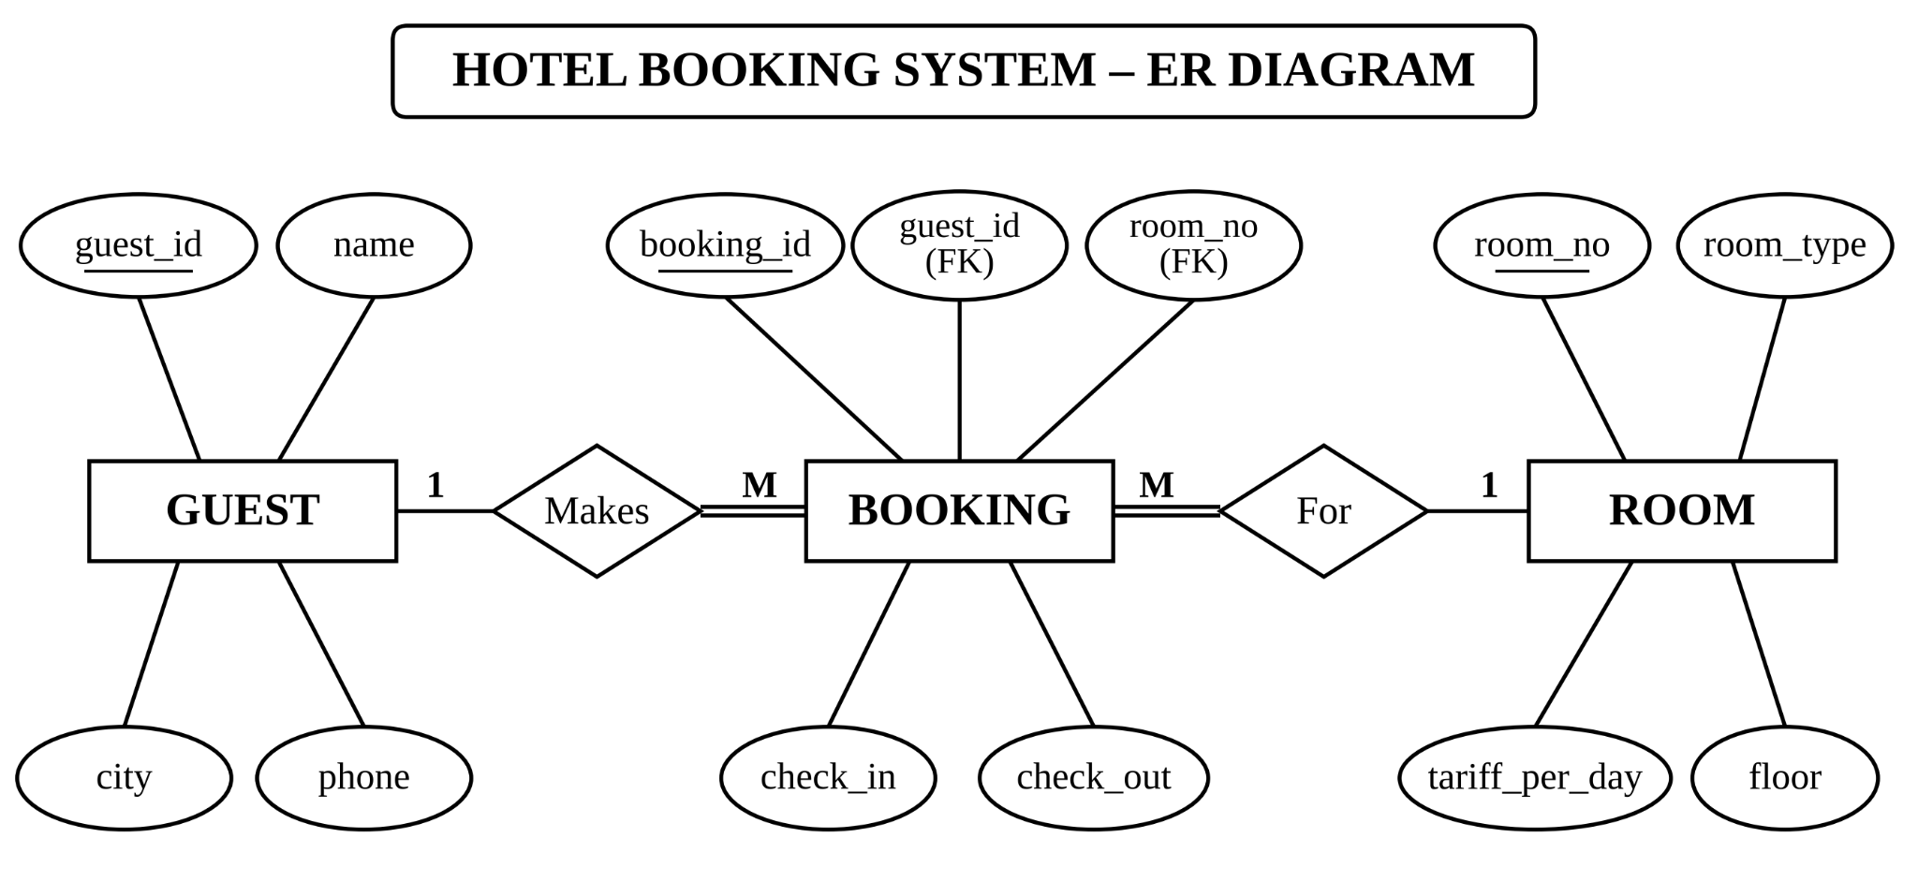

Figure 9: ER diagram of the Hotel Room Booking System using Chen notation.
The foreign keys booking.guest_id and booking.room_no implement these relationships in MySQL.

9. Database Connectivity Using PHP
The file db.php establishes the connection between the PHP application and the MySQL database. It creates a MySQLi connection to the local XAMPP MySQL server using localhost, the root username, an empty password and the database name hotel_db. If the connection fails, the page displays a database connection error and stops.
<?php
// db.php - shared database connection (included by booking.php and report.php)
$host = "localhost";
$user = "root"; // XAMPP default user
$pass = ""; // XAMPP default password (empty)
$dbname = "hotel_db";

mysqli_report(MYSQLI_REPORT_OFF); // errors are handled manually so we can show friendly messages

$conn = new mysqli($host, $user, $pass, $dbname);

if ($conn->connect_error) {
die("Database connection failed: " . htmlspecialchars($conn->connect_error));
}
$conn->set_charset("utf8mb4");

The variable $conn stores the database connection. The booking.php and report.php pages include db.php and use this connection to execute SQL queries.

10. Working of the System

10.1 Booking Entry Form
The booking.php page provides the entry form for creating a new room booking. The guest list is obtained from the guest table, and the room types are obtained from the room table. The user selects the check-in and check-out dates and can optionally filter the available rooms by room type.
The system checks room availability by searching for bookings that overlap the selected dates. A room is displayed only when no existing booking for that room overlaps the requested stay. The user then selects an available room and a guest and submits the form.
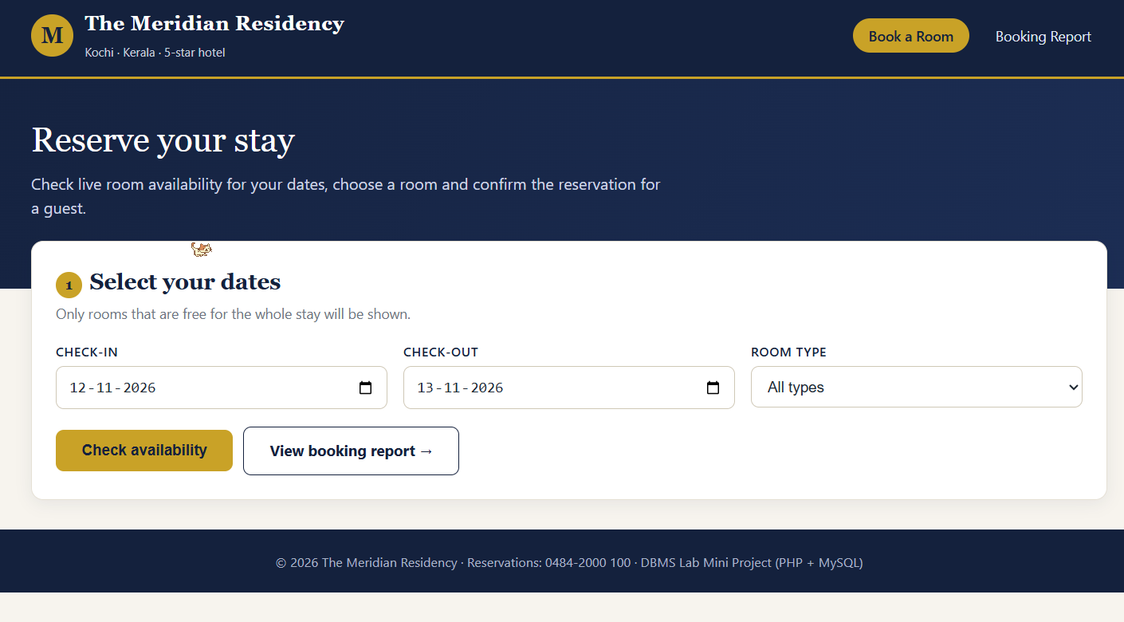
Figure 10(a) : Booking Entry Form

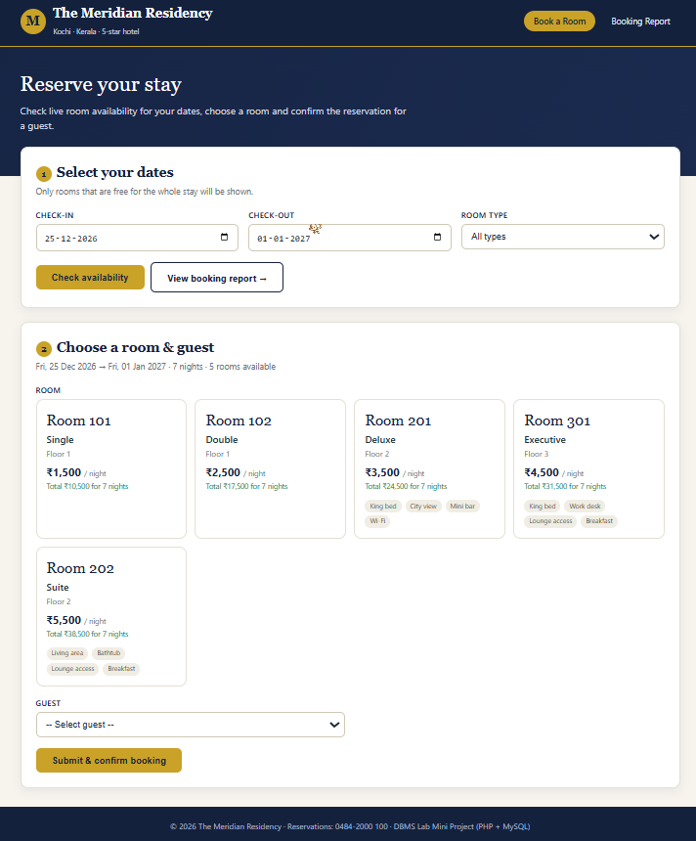
Figure 10(b) : Room Availability Check
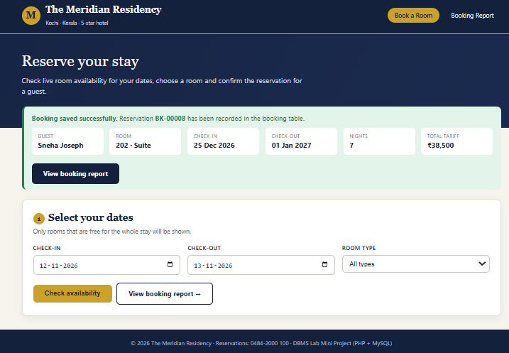
Figure 10(c) : Successful Booking Confirmation

When the form is submitted through HTTP POST, PHP reads the selected guest ID, room number, check-in date and check-out date. It validates the values and checks availability again before inserting the booking. A prepared INSERT statement is used to save the values into the booking table. The booking_id is generated automatically because it is defined as AUTO_INCREMENT. After a successful insert, the page redirects and displays a confirmation message with the booking details.
The room availability query uses NOT EXISTS to exclude rooms having an overlapping booking. The main insertion operation is:
INSERT INTO booking (guest_id, room_no, check_in, check_out)
VALUES (?, ?, ?, ?);
The complete code of booking.php is given below.
<?php
// booking.php - Page 1: reservation desk (entry page for the booking table)
include 'db.php';

$today = date('Y-m-d');
$error = "";

/* Amenities shown on room cards (display only) */
$amenities = [
"Standard Single" => ["Single bed", "Wi-Fi", "AC"],
"Standard Double" => ["Double bed", "Wi-Fi", "AC", "TV"],
"Deluxe" => ["King bed", "City view", "Mini bar", "Wi-Fi"],
"Executive" => ["King bed", "Work desk", "Lounge access", "Breakfast"],
"Suite" => ["Living area", "Bathtub", "Lounge access", "Breakfast"],
];

function nights_between($in, $out) {
return (int)((strtotime($out) - strtotime($in)) / 86400);
}

/* Is a room free for the given dates? (no overlapping booking) */
function room_is_free($conn, $room_no, $in, $out) {
$stmt = $conn->prepare(
"SELECT COUNT(*) FROM booking WHERE room_no = ? AND check_in < ? AND check_out > ?"
);
$stmt->bind_param("iss", $room_no, $out, $in);
$stmt->execute();
$stmt->bind_result($n);
$stmt->fetch();
$stmt->close();
return $n == 0;
}

/* ---------- Handle form submit (POST): INSERT into booking ---------- */
if ($_SERVER["REQUEST_METHOD"] === "POST") {
$guest_id = (int)($_POST["guest_id"] ?? 0);
$room_no = (int)($_POST["room_no"] ?? 0);
$check_in = $_POST["check_in"] ?? "";
$check_out = $_POST["check_out"] ?? "";

$validDates = preg_match('/^\d{4}-\d{2}-\d{2}$/', $check_in) && preg_match('/^\d{4}-\d{2}-\d{2}$/', $check_out);

if ($guest_id <= 0 || $room_no <= 0 || !$validDates) {
$error = "Please select a guest and a room before confirming the booking.";
} elseif ($check_out <= $check_in) {
$error = "Check-out date must be after the check-in date.";
} elseif ($check_in < $today) {
$error = "Check-in date cannot be in the past.";
} elseif (!room_is_free($conn, $room_no, $check_in, $check_out)) {
$error = "Sorry, room $room_no was just booked for those dates. Please choose another room.";
} else {
$stmt = $conn->prepare(
"INSERT INTO booking (guest_id, room_no, check_in, check_out) VALUES (?, ?, ?, ?)"
);
$stmt->bind_param("iiss", $guest_id, $room_no, $check_in, $check_out);
if ($stmt->execute()) {
$id = $conn->insert_id;
$stmt->close();
header("Location: booking.php?saved=" . $id); // redirect so refresh does not re-submit
exit;
}
$error = "The booking could not be saved. " . $stmt->error;
$stmt->close();
}
// keep the dates so the user can retry
$_GET["check_in"] = $check_in;
$_GET["check_out"] = $check_out;
$_GET["search"] = 1;
}

/* ---------- Confirmation of a saved booking (SELECT with join) ---------- */
$saved = null;
if (isset($_GET["saved"])) {
$sid = (int)$_GET["saved"];
$stmt = $conn->prepare(
"SELECT b.booking_id, g.name, g.phone, r.room_no, r.room_type, r.tariff_per_day, b.check_in, b.check_out
FROM booking b
JOIN guest g ON b.guest_id = g.guest_id
JOIN room r ON b.room_no = r.room_no
WHERE b.booking_id = ?"
);
$stmt->bind_param("i", $sid);
$stmt->execute();
$saved = $stmt->get_result()->fetch_assoc();
$stmt->close();
}

/* ---------- Availability search (GET) ---------- */
$in = $_GET["check_in"] ?? $today;
$out = $_GET["check_out"] ?? date('Y-m-d', strtotime('+1 day'));
$searched = isset($_GET["search"]);
$available = [];
$nights = 0;

if ($searched) {
if (!preg_match('/^\d{4}-\d{2}-\d{2}$/', $in) || !preg_match('/^\d{4}-\d{2}-\d{2}$/', $out)) {
$error = $error ?: "Please enter valid dates.";
$searched = false;
} elseif ($out <= $in) {
$error = $error ?: "Check-out date must be after the check-in date.";
$searched = false;
} elseif ($in < $today) {
$error = $error ?: "Check-in date cannot be in the past.";
$searched = false;
} else {
$nights = nights_between($in, $out);
$filter = $_GET["type"] ?? "";
$sql = "SELECT r.room_no, r.room_type, r.tariff_per_day, r.floor
FROM room r
WHERE NOT EXISTS (
SELECT 1 FROM booking b
WHERE b.room_no = r.room_no AND b.check_in < ? AND b.check_out > ?
)";
if ($filter !== "") {
$sql .= " AND r.room_type = ?";
}
$sql .= " ORDER BY r.tariff_per_day, r.room_no";
$stmt = $conn->prepare($sql);
if ($filter !== "") {
$stmt->bind_param("sss", $out, $in, $filter);
} else {
$stmt->bind_param("ss", $out, $in);
}
$stmt->execute();
$available = $stmt->get_result()->fetch_all(MYSQLI_ASSOC);
$stmt->close();
}
}

$guests = $conn->query("SELECT guest_id, name, city FROM guest ORDER BY name")->fetch_all(MYSQLI_ASSOC);
$types = $conn->query("SELECT DISTINCT room_type FROM room ORDER BY room_type")->fetch_all(MYSQLI_ASSOC);

$pageTitle = "Book a Room";
$active = "book";
include 'header.php';
?>
<section class="hero">
<div class="wrap">
<h1>Reserve your stay</h1>
<p>Check live room availability for your dates, choose a room and confirm the reservation for a guest.</p>
</div>
</section>

<main class="wrap pull-up">

<?php if ($saved): ?>
<?php $n = nights_between($saved["check_in"], $saved["check_out"]); ?>
<div class="alert success">
<strong>Booking saved successfully.</strong> Reservation <b>BK-<?= str_pad($saved["booking_id"], 5, "0", STR_PAD_LEFT) ?></b> has been recorded in the booking table.
<div class="confirm">
<div><span>Guest</span><b><?= htmlspecialchars($saved["name"]) ?></b></div>
<div><span>Room</span><b><?= $saved["room_no"] ?> &middot; <?= htmlspecialchars($saved["room_type"]) ?></b></div>
<div><span>Check-in</span><b><?= date('d M Y', strtotime($saved["check_in"])) ?></b></div>
<div><span>Check-out</span><b><?= date('d M Y', strtotime($saved["check_out"])) ?></b></div>
<div><span>Nights</span><b><?= $n ?></b></div>
<div><span>Total tariff</span><b>&#8377;<?= number_format($n * $saved["tariff_per_day"]) ?></b></div>
</div>
<div class="actions"><a class="btn dark" href="report.php">View booking report</a></div>
</div>
<?php endif; ?>

<?php if ($error): ?>
<div class="alert error"><strong>Error:</strong> <?= htmlspecialchars($error) ?></div>
<?php endif; ?>

<!-- Step 1: dates -->
<section class="card">
<h2><span class="step">1</span>Select your dates</h2>
<p class="sub">Only rooms that are free for the whole stay will be shown.</p>
<form method="get" action="booking.php">
<input type="hidden" name="search" value="1">
<div class="grid g3">
<div>
<label class="lbl" for="check_in">Check-in</label>
<input type="date" id="check_in" name="check_in" min="<?= $today ?>" value="<?= htmlspecialchars($in) ?>" required>
</div>
<div>
<label class="lbl" for="check_out">Check-out</label>
<input type="date" id="check_out" name="check_out" min="<?= $today ?>" value="<?= htmlspecialchars($out) ?>" required>
</div>
<div>
<label class="lbl" for="type">Room type</label>
<select id="type" name="type">
<option value="">All types</option>
<?php foreach ($types as $t): ?>
<option value="<?= htmlspecialchars($t["room_type"]) ?>" <?= (($_GET["type"] ?? "") === $t["room_type"]) ? "selected" : "" ?>>
<?= htmlspecialchars($t["room_type"]) ?>
</option>
<?php endforeach; ?>
</select>
</div>
</div>
<div class="actions">
<button class="btn" type="submit">Check availability</button>
<a class="btn ghost" href="report.php">View booking report &rarr;</a>
</div>
</form>
</section>

<!-- Step 2: choose room + guest, then submit -->
<?php if ($searched): ?>
<section class="card">
<h2><span class="step">2</span>Choose a room &amp; guest</h2>
<p class="sub">
<?= date('D, d M Y', strtotime($in)) ?> &rarr; <?= date('D, d M Y', strtotime($out)) ?>
&middot; <?= $nights ?> night<?= $nights > 1 ? "s" : "" ?>
&middot; <?= count($available) ?> room<?= count($available) == 1 ? "" : "s" ?> available
</p>

<?php if (!$available): ?>
<div class="alert info">No rooms are available for these dates. Try different dates or another room type.</div>
<?php else: ?>
<form method="post" action="booking.php">
<input type="hidden" name="check_in" value="<?= htmlspecialchars($in) ?>">
<input type="hidden" name="check_out" value="<?= htmlspecialchars($out) ?>">

<label class="lbl">Room</label>
<div class="rooms">
<?php foreach ($available as $i => $r): ?>
<label class="room-opt">
<input type="radio" name="room_no" value="<?= $r["room_no"] ?>" required <?= $i === 0 ? "" : "" ?>>
<div class="room-card">
<div class="room-no">Room <?= $r["room_no"] ?></div>
<div class="room-type"><?= htmlspecialchars($r["room_type"]) ?></div>
<div class="room-meta">Floor <?= $r["floor"] ?></div>
<div class="room-price">&#8377;<?= number_format($r["tariff_per_day"]) ?> <small>/ night</small></div>
<div class="room-total">Total &#8377;<?= number_format($r["tariff_per_day"] * $nights) ?> for <?= $nights ?> night<?= $nights > 1 ? "s" : "" ?></div>
<div class="chips">
<?php foreach (($amenities[$r["room_type"]] ?? []) as $a): ?>
<span class="chip"><?= htmlspecialchars($a) ?></span>
<?php endforeach; ?>
</div>
</div>
</label>
<?php endforeach; ?>
</div>

<div class="grid g2" style="margin-top:18px">
<div>
<label class="lbl" for="guest_id">Guest</label>
<select id="guest_id" name="guest_id" required>
<option value="">-- Select guest --</option>
<?php foreach ($guests as $g): ?>
<option value="<?= $g["guest_id"] ?>"><?= htmlspecialchars($g["name"]) ?> &middot; <?= htmlspecialchars($g["city"]) ?></option>
<?php endforeach; ?>
</select>
</div>
</div>

<div class="actions">
<button class="btn" type="submit">Submit &amp; confirm booking</button>
</div>
</form>
<?php endif; ?>
</section>
<?php endif; ?>

</main>
<?php include 'footer.php'; ?>

10.2 Displaying the Booking Report
The report.php page displays the booking details in an HTML table. It retrieves the guest name from the guest table, the room number and room type from the room table, and the check-in and check-out dates from the booking table. The report also displays additional information such as the number of nights, calculated amount and booking status. Search filters, room-type filters, status filters and pagination are provided.

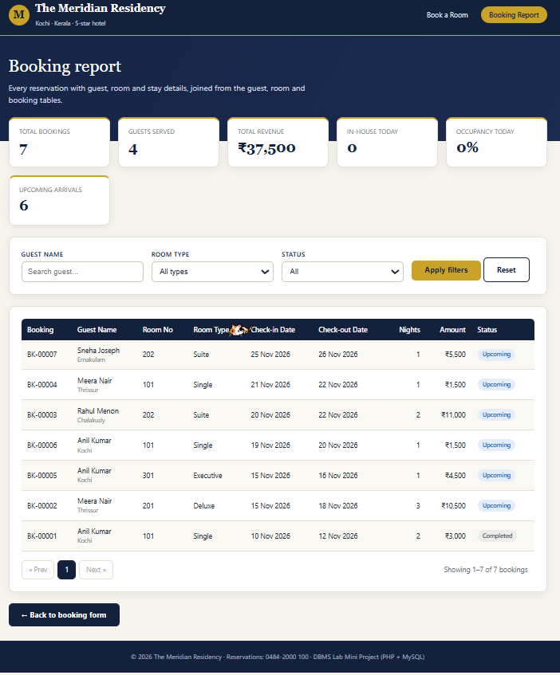
Figure 11: Booking report displaying guest, room and booking date details.

An INNER JOIN operation combines the three tables by matching guest_id and room_no values. The query used to retrieve the report information is:
SELECT
g.name,
r.room_no,
r.room_type,
b.check_in,
b.check_out
FROM booking b
INNER JOIN guest g ON b.guest_id = g.guest_id
INNER JOIN room r ON b.room_no = r.room_no;
The complete code of report.php is given below.
<?php
// report.php - Page 2: booking report (JOIN of booking + guest + room)
include 'db.php';

/* ---------- Filters (GET) ---------- */
$q = trim($_GET["q"] ?? "");
$type = $_GET["type"] ?? "";
$status = $_GET["status"] ?? "";
$page = max(1, (int)($_GET["page"] ?? 1));
$perPage = 15;

$statusSql = "CASE
WHEN b.check_out <= CURDATE() THEN 'Completed'
WHEN b.check_in > CURDATE() THEN 'Upcoming'
ELSE 'In-house'
END";

$where = [];
$params = [];
$ptypes = "";
if ($q !== "") {
$where[] = "g.name LIKE ?";
$params[] = "%" . $q . "%";
$ptypes .= "s";
}
if ($type !== "") {
$where[] = "r.room_type = ?";
$params[] = $type;
$ptypes .= "s";
}
if (in_array($status, ["Completed", "Upcoming", "In-house"], true)) {
$where[] = "($statusSql) = ?";
$params[] = $status;
$ptypes .= "s";
}
$whereSql = $where ? "WHERE " . implode(" AND ", $where) : "";

$fromSql = "FROM booking b
JOIN guest g ON b.guest_id = g.guest_id
JOIN room r ON b.room_no = r.room_no";

/* ---------- Summary cards ---------- */
$stats = $conn->query(
"SELECT COUNT(*) AS total,
COUNT(DISTINCT b.guest_id) AS guests,
COALESCE(SUM(DATEDIFF(b.check_out, b.check_in) * r.tariff_per_day), 0) AS revenue,
COALESCE(SUM(b.check_in <= CURDATE() AND b.check_out > CURDATE()), 0) AS inhouse,
COALESCE(SUM(b.check_in > CURDATE()), 0) AS upcoming
$fromSql"
)->fetch_assoc();
$totalRooms = (int)$conn->query("SELECT COUNT(*) FROM room")->fetch_row()[0];
$occupancy = $totalRooms ? round($stats["inhouse"] * 100 / $totalRooms) : 0;

/* ---------- Count for pagination ---------- */
$stmt = $conn->prepare("SELECT COUNT(*) $fromSql $whereSql");
if ($params) { $stmt->bind_param($ptypes, ...$params); }
$stmt->execute();
$stmt->bind_result($totalRows);
$stmt->fetch();
$stmt->close();

$pages = max(1, (int)ceil($totalRows / $perPage));
$page = min($page, $pages);
$offset = ($page - 1) * $perPage;

/* ---------- The report: join of the three tables ---------- */
$sql = "SELECT b.booking_id, g.name, g.city, r.room_no, r.room_type, r.tariff_per_day,
b.check_in, b.check_out,
DATEDIFF(b.check_out, b.check_in) AS nights,
DATEDIFF(b.check_out, b.check_in) * r.tariff_per_day AS amount,
$statusSql AS status
$fromSql
$whereSql
ORDER BY b.check_in DESC, b.booking_id DESC
LIMIT $perPage OFFSET $offset";
$stmt = $conn->prepare($sql);
if ($params) { $stmt->bind_param($ptypes, ...$params); }
$stmt->execute();
$rows = $stmt->get_result()->fetch_all(MYSQLI_ASSOC);
$stmt->close();

$types = $conn->query("SELECT DISTINCT room_type FROM room ORDER BY room_type")->fetch_all(MYSQLI_ASSOC);

function page_link($p) {
$qs = $_GET;
$qs["page"] = $p;
return "report.php?" . htmlspecialchars(http_build_query($qs));
}
$badge = ["In-house" => "in", "Upcoming" => "up", "Completed" => "done"];

$pageTitle = "Booking Report";
$active = "report";
include 'header.php';
?>
<section class="hero">
<div class="wrap">
<h1>Booking report</h1>
<p>Every reservation with guest, room and stay details, joined from the guest, room and booking tables.</p>
</div>
</section>

<main class="wrap pull-up">

<div class="stats">
<div class="stat"><span>Total bookings</span><b><?= number_format($stats["total"]) ?></b></div>
<div class="stat"><span>Guests served</span><b><?= $stats["guests"] ?></b></div>
<div class="stat"><span>Total revenue</span><b>&#8377;<?= number_format($stats["revenue"]) ?></b></div>
<div class="stat"><span>In-house today</span><b><?= $stats["inhouse"] ?></b></div>
<div class="stat"><span>Occupancy today</span><b><?= $occupancy ?>%</b></div>
<div class="stat"><span>Upcoming arrivals</span><b><?= $stats["upcoming"] ?></b></div>
</div>

<section class="card">
<form method="get" action="report.php">
<div class="grid g4">
<div>
<label class="lbl" for="q">Guest name</label>
<input type="text" id="q" name="q" value="<?= htmlspecialchars($q) ?>" placeholder="Search guest...">
</div>
<div>
<label class="lbl" for="type">Room type</label>
<select id="type" name="type">
<option value="">All types</option>
<?php foreach ($types as $t): ?>
<option value="<?= htmlspecialchars($t["room_type"]) ?>" <?= $type === $t["room_type"] ? "selected" : "" ?>><?= htmlspecialchars($t["room_type"]) ?></option>
<?php endforeach; ?>
</select>
</div>
<div>
<label class="lbl" for="status">Status</label>
<select id="status" name="status">
<option value="">All</option>
<?php foreach (["In-house", "Upcoming", "Completed"] as $s): ?>
<option <?= $status === $s ? "selected" : "" ?>><?= $s ?></option>
<?php endforeach; ?>
</select>
</div>
<div style="align-self:end">
<button class="btn" type="submit">Apply filters</button>
<a class="btn ghost" href="report.php">Reset</a>
</div>
</div>
</form>
</section>

<section class="card">
<div class="tbl-wrap">
<?php if (!$rows): ?>
<div class="empty">No bookings match your filters.</div>
<?php else: ?>
<table class="data">
<tr>
<th>Booking</th>
<th>Guest Name</th>
<th>Room No</th>
<th>Room Type</th>
<th>Check-in Date</th>
<th>Check-out Date</th>
<th class="num">Nights</th>
<th class="num">Amount</th>
<th>Status</th>
</tr>
<?php foreach ($rows as $r): ?>
<tr>
<td>BK-<?= str_pad($r["booking_id"], 5, "0", STR_PAD_LEFT) ?></td>
<td><?= htmlspecialchars($r["name"]) ?><span class="guest-city"><?= htmlspecialchars($r["city"]) ?></span></td>
<td><?= $r["room_no"] ?></td>
<td><?= htmlspecialchars($r["room_type"]) ?></td>
<td><?= date('d M Y', strtotime($r["check_in"])) ?></td>
<td><?= date('d M Y', strtotime($r["check_out"])) ?></td>
<td class="num"><?= $r["nights"] ?></td>
<td class="num">&#8377;<?= number_format($r["amount"]) ?></td>
<td><span class="badge <?= $badge[$r["status"]] ?>"><?= $r["status"] ?></span></td>
</tr>
<?php endforeach; ?>
</table>

<div class="pager">
<?php if ($page > 1): ?><a href="<?= page_link($page - 1) ?>">&laquo; Prev</a><?php else: ?><span class="dis">&laquo; Prev</span><?php endif; ?>
<?php for ($p = max(1, $page - 2); $p <= min($pages, $page + 2); $p++): ?>
<?php if ($p == $page): ?><span class="cur"><?= $p ?></span><?php else: ?><a href="<?= page_link($p) ?>"><?= $p ?></a><?php endif; ?>
<?php endfor; ?>
<?php if ($page < $pages): ?><a href="<?= page_link($page + 1) ?>">Next &raquo;</a><?php else: ?><span class="dis">Next &raquo;</span><?php endif; ?>
<span class="count" style="border:0;background:none">Showing <?= $offset + 1 ?>&ndash;<?= $offset + count($rows) ?> of <?= $totalRows ?> bookings</span>
</div>
<?php endif; ?>
</div>
</section>

<div class="actions" style="margin-top:0">
<a class="btn dark" href="booking.php">&larr; Back to booking form</a>
</div>
</main>
<?php include 'footer.php'; ?>

11. Overall System Workflow
- The user opens the booking form (booking.php) in the browser.
- The user selects the check-in and check-out dates and optionally chooses a room type.
- PHP retrieves the rooms that are available for the selected dates.
- The user selects an available room and a guest from the displayed options.
- When the form is submitted, PHP validates the dates and selected IDs and checks room availability again.
- PHP inserts the booking details into the booking table using a prepared statement.
- The database checks the foreign key references to ensure that the guest and room IDs exist.
- The page displays a confirmation message after a successful booking.
- The report page (report.php) uses JOIN operations to combine information from all three tables.
- The final report displays the guest name, room number, room type, check-in date and check-out date.

12. Result
The Hotel Room Booking System was designed and implemented using PHP and MySQL. The database stores guest, room and booking information in three related tables. The booking form checks room availability and inserts booking details into the booking table. The report page retrieves and displays the combined information from the guest, room and booking tables using SQL JOIN operations.

13. Conclusion
This project demonstrates the practical use of relational database concepts such as table creation, primary keys, foreign keys, referential integrity, data insertion and SQL joins. It also demonstrates how PHP can connect to a MySQL database, execute prepared INSERT statements and SELECT queries, validate booking details and display database records through web pages.

Appendix: Supporting Project Files
The project also uses header.php and footer.php for the common page layout and style.css for the visual design. These files are included by the entry and report pages.

A. header.php
<?php
// header.php - shared page header + navigation. Set $pageTitle and $active before including.
$pageTitle = $pageTitle ?? "The Meridian Residency";
$active = $active ?? "";
?>
<!DOCTYPE html>
<html lang="en">
<head>
<meta charset="UTF-8">
<meta name="viewport" content="width=device-width, initial-scale=1">
<title><?= htmlspecialchars($pageTitle) ?> | The Meridian Residency</title>
<link rel="stylesheet" href="style.css">
</head>
<body>
<header class="topbar">
<div class="wrap topbar-in">
<a class="brand" href="booking.php">
<span class="brand-mark">M</span>
<span><strong>The Meridian Residency</strong><small>Kochi &middot; Kerala &middot; 5-star hotel</small></span>
</a>
<nav>
<a href="booking.php" class="<?= $active === 'book' ? 'on' : '' ?>">Book a Room</a>
<a href="report.php" class="<?= $active === 'report' ? 'on' : '' ?>">Booking Report</a>
</nav>
</div>
</header>

B. footer.php
<footer class="foot">
<div class="wrap">
&copy; <?= date('Y') ?> The Meridian Residency &middot; Reservations: 0484-2000 100 &middot; DBMS Lab Mini Project (PHP + MySQL)
</div>
</footer>
</body>
</html>

The SQL database export is provided separately as hotel_db.sql. It contains the CREATE TABLE statements, primary key and foreign key constraints, and sample records for the guest, room and booking tables.
Before final submission, enter the correct roll number in the report and insert the actual screenshots in Figures 1–11. The screenshots should be captured from the user's own XAMPP/phpMyAdmin execution.

